

University of the Philippines Cebu

Gorordo Avenue, Lahug, Cebu CIty

College of Science

Department of Computer Science

CMSC 178

Topics in Software Technology

FLY WARS

Micah Nicole J. Chu Im

BS Computer Science 3

Project Summary/Description

1.1 Game Concept and Look

Inspired from the game Space Impact, the player must kill all enemies. It is a one player game where he/she has a spaceship or his/her shooter and the player must use the spacebar to attack.

In the game screen you’ll see a galaxy. Your spaceship is at the lower center of the screen at default. An enemy will be spawned as soon as the game starts. The enemies will move vertically. You’ll know you hit an enemy when the it is gone from the screen.

1.2 Gameplay

The player has the ability to move freely vertically. The player will use the arrow keys to navigate vertically. The enemies are spawned randomly. The player would then try to hit or kill the enemies with his bullets. The player must press the spacebar to activate his bullets.

The enemies or flies spawn at random points at the upper half of the screen. When a fly hits the spaceship, the player will lose a life. The player will gain points if he or she successfully hit a fly.

There is no win condition for the player, you just have to survive. When the player’s life reaches zero, the game is over.

1.3 Objective

To keep the player’s life above zero.

2. System Specifications

2.1 Procedures

2.1.1 Main

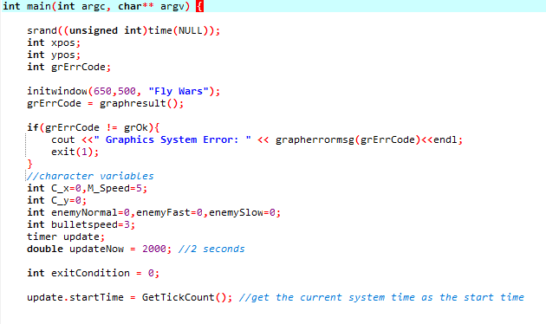

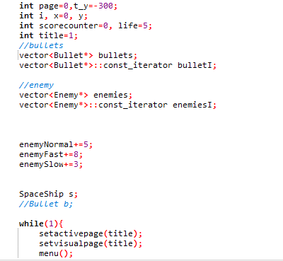

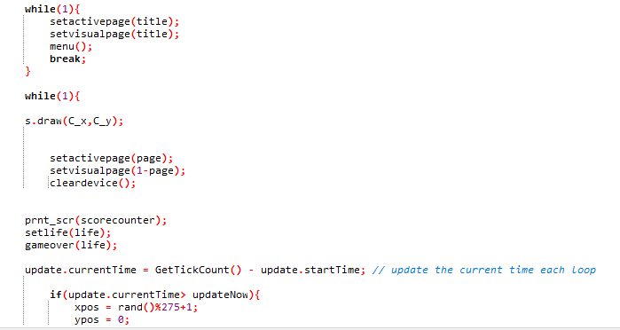

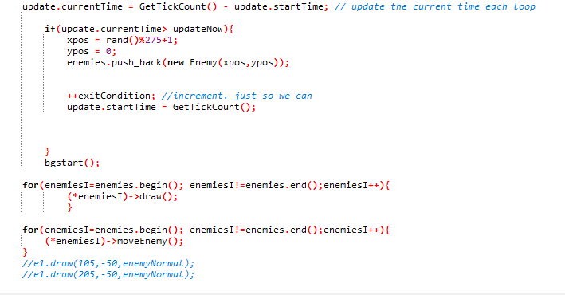

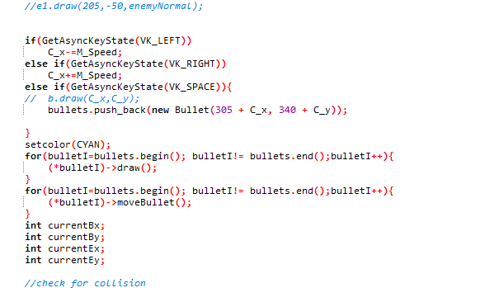

The movement of the player’s logic is placed in the main.if(GetAsyncKeyState(VK_LEFT)

checks if the player pressed the left key. The spaceship moves when the player press the left arrow key. The spaceship moves to the right when he or she pressed the right arrow key.

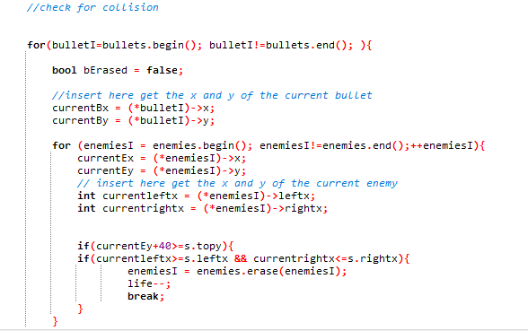

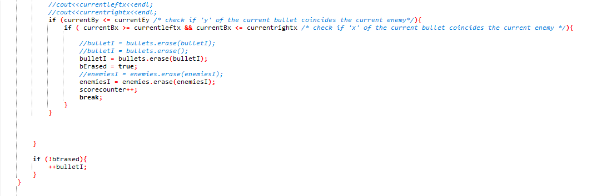

In the main, there is a checker for collision. If the bullet hits the enemy, the player’s score will increase. Also if the enemy hits the player, his or her life decreases.

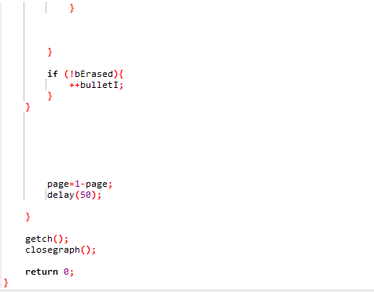

2.1.2 Main Menu

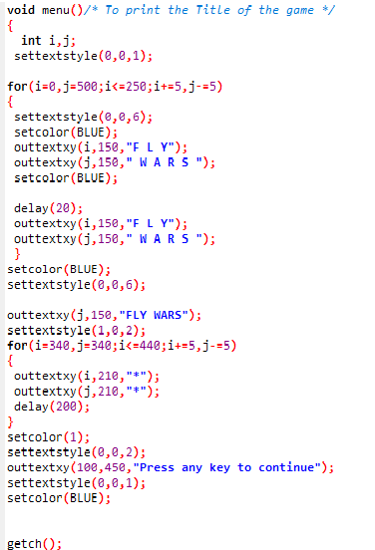

This is the main menu function. This will be the first screen the player will see when he or she runs the game.

2.1.3 bgstart

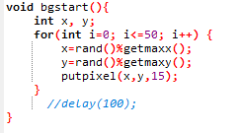

This is a function for the galaxy like background.

2.1.4 prnt_scr

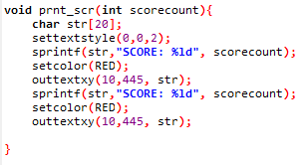

This is the print score function. This is the one incharge of printing and updating the score.

2.1.5 setlife

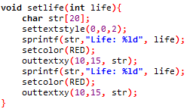

This is the setlife function. This is the one incharge of printing and updating the player’s life.

2.1.6 gameover

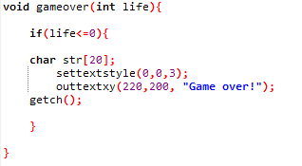

This is the game over function. This checks if the player’s life is 0. The game pauses, and a game over text appears on screen when the player’s life is 0.

2.2 Classes

2.2.1 Spaceship

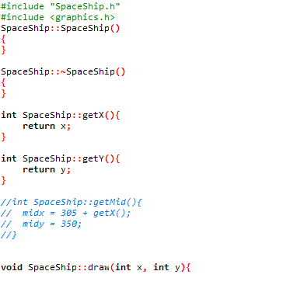

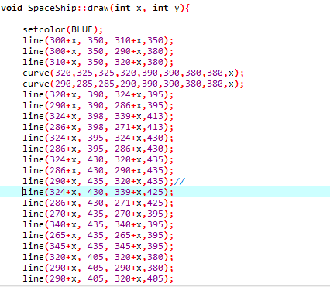

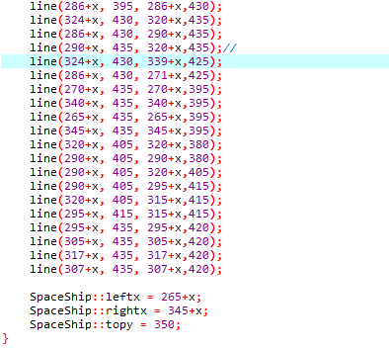

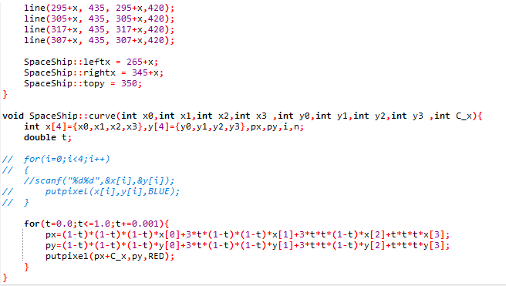

This is the spaceship class. It has its own draw class.

2.2.2 Bullet

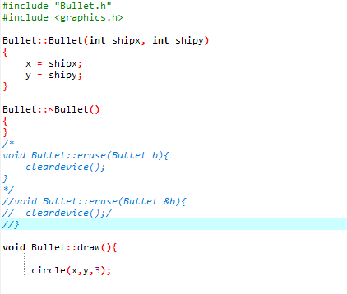

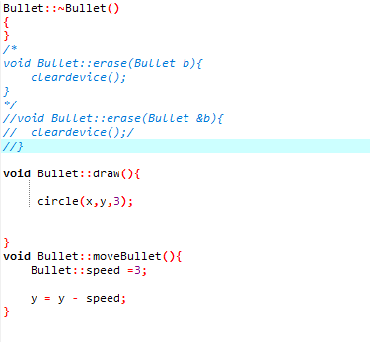

This is the bullet class. It has its own draw function and its move function.

2.2.3 Enemy

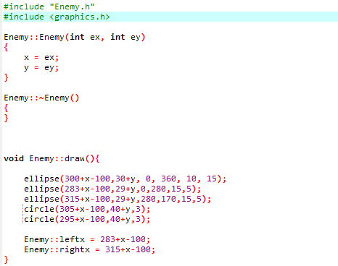

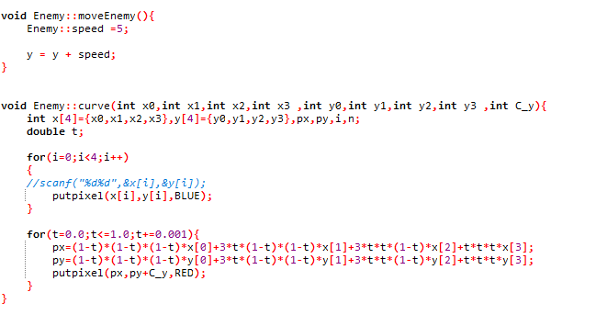

This is the enemy class. It has its own move function and draw function.

3. Screen Cap of the Game (w/ description)

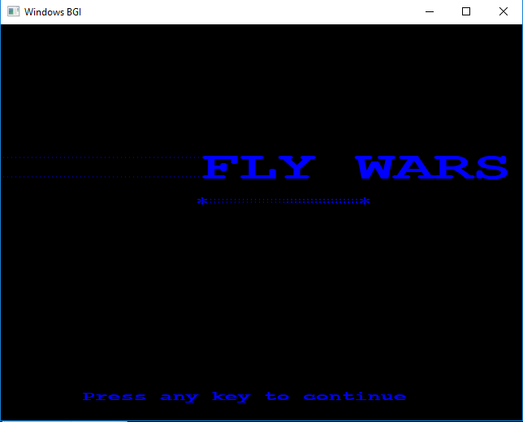

This is the Main Menu of the Game.

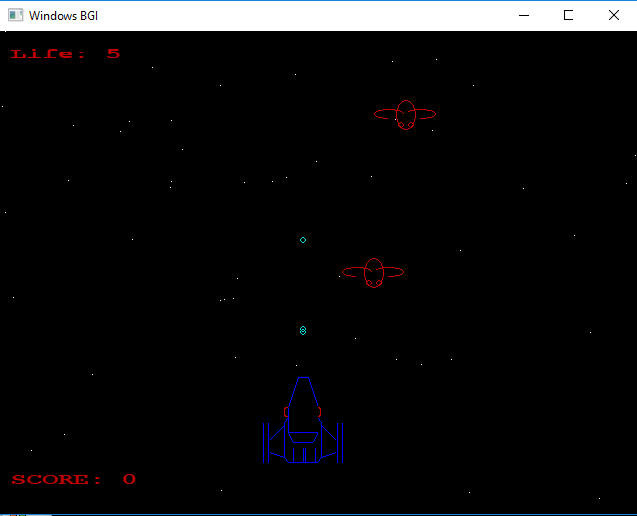

This is the game screen. The player will see his or her score and his or her remaining lives. The player is going to control the spaceship and those flies are the enemies. The player’s bullets will come out every time he or she will press the spacebar.

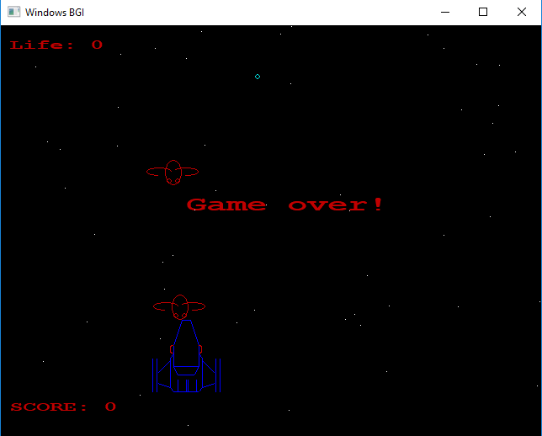

This is the game over screen. When the player’s life reaches zero, the game is over.